4.import java.util.*;

public class Main{

static int factorial(int a)
{
int res = 1;
for (int m = 2; m <= a; m++)
res *= m;
return res;
}

static double sum(int a)
{
double sum = 0;
for (int m = 1; m <= a; m++)
sum += 1.0/factorial(m);
return sum;
}

public static void main (String[] args)
{
System.out.println("Author:J.GOPI VENKATA SAI\nSAP ID:51834677");
int a = 5;
System.out.println(sum(a));
}
}

OUTPUT:
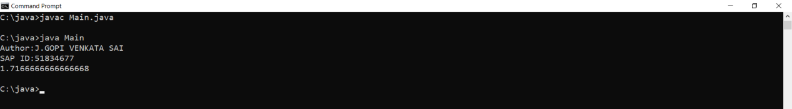

5.import java.util.*;

public class Main
{

static int summation(int a)
{
System.out.println("Author:J.GOPI VENKATA SAI\nSAP ID:51834677");
int sum = 0, y = 1;
for (int x = 1; x <= a; x++)
{
sum = sum + y;
y = (y * 10) + 1;
}

return sum;
}

public static void main(String args[])
{
int a = 5;
System.out.println(summation(a));
}
}

OUTPUT:
